8-Growth

The purpose of this module is to calculate the mass of seven live pools of carbon: 1) foliage, 2) fine roots, 3) branches, 4) sapwood, 5) heartwood, 6) heartrot, and 7) coarse roots. To avoid confusion with the corresponding detrital pools, we have referred to these live pools as parts. The functions in GROWTH are invoked each year for each cohort before any disturbance occurs.

This module is divided into eleven functions which perform specific tasks. These include: 1) Light Absorption and Foliage, 2) Foliage Age-class Adjustment 3) Hydraulics, 4) Allocation, 5) Respiration, 6) Heartwood Formation, 7) Heartrot, 8) Mortality, 9) Prune, 10) Live Stores, and 11) Volume (note not yet implemented). Each of these functions is invoked for each plant layer present in a cohort.

The parts present depend on the plant layers present in a cohort. Herbs are assumed to have leaves and fine roots only. Shrubs have leaves, fine roots, branches, sapwood, and coarse roots. Trees have leaves, fine roots, branches, sapwood, heartwood, heartrot, and coarse roots. Boles are divided into three pools: sapwood, heartwood, and heartrot. Sapwood and heart-rots represents respiring tissue, whereas heartwood represents non-respiring tissue. Heartrot represents a part of the bole that is decomposing. Splitting the bole into these parts also allows one to have the decomposition of dead wood as a function of decay-resistance of the heartwood of the tree species growing in a plot.

The mass of parts calculated in this module are in turn used by CLIMATE, MORTALITY, DECOMPOSE, HARVEST, PERSCRIBED FIRE, and WILDFIRE.

The files directly used by the GROWTH module to define parameters includes Growth.prm and GrowLayer.prm.

Light Absorption and Foliage Function

This function determines the growth of the foliage layers and the amount of light absorbed by them (Figure 8-1). Light is expressed in relative terms as a percentage of full sunlight. We assume that taller layers have a competitive advantage over shorter stature layers; if taller layers are present they will absorb light before underlying layers. Therefore, in this model smaller stature layers do not have the ability to exclude potentially taller layers such as trees. This behavior can, however, be simulated by reducing the colonization rate of the upper and lower tree layers in the PLANT module (see Estab.prm file). In addition to being reduced by taller layers by shading from above, light coming into a plant layer can be reduced by shading from trees within cohorts, as well as surrounding cohorts and stand grid cells (see NEIGHBOR).

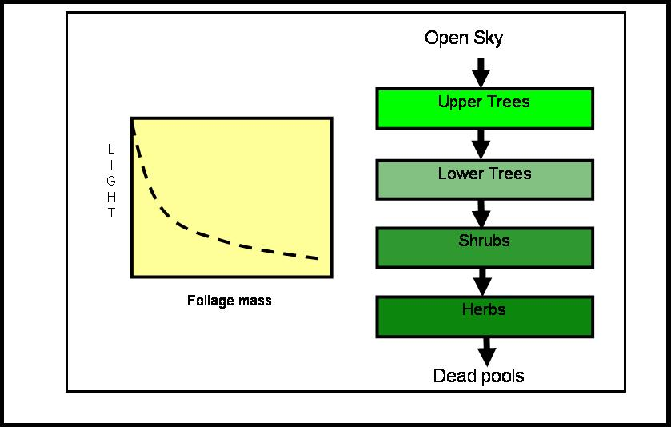

Figure 8-1. Movement of light through the LANDCARB model and removal of light by foliage.

The foliage mass of a layer (LayerFoliage) will not begin to grow until a small mass of foliage is added to the foliage part of a layer in a cohort by PLANT. This allows the mass of foliage to increase at a rate dependent upon the amount of remaining light. Before a layer is planted the following condition is present:

The LayerFoliageProdRate=0

and

LayerFoliage=0

As soon as a layer is planted these variables are set:

FoliageProdEffic=1

and

Foliage=InitialFoliageMass

where InitialFoliageMass is the initial mass of foliage that is planted. InitialFoliageMass can be varied (See the GrowParm.prm file) to introduce a lag in the time required for a layer to grow significantly. By reducing this parameter one increases the lag in the growth of a layer. Foliage production rate is an index that indicates the relative ability of foliage to produce more foliage. When this variable is 1, foliage increases at the maximum rate. When this variable is 0, foliage does not increase and when it is negative (i.e., an overlying layer establishes and absorbs too much light) the foliage mass decreases.

Layers are able to increase their foliage mass until the light compensation point (LightCompPoint) for that layer or species of tree is reached. As overlying layers can absorb light, the foliage growth of underlying layers can be far below that expected for full sunlight. This approach also allows the foliage of the underlying layers to change in response to an overlying layer dying out or to an overlying layer establishing.

The first step to calculate the rate that foliage increases is to convert LightCompPoint from a percentage to a proportion:

LayerLightCompPoint=LayerLightCompPoint/100

The next step is to calculate the potential maximum of light (LayerMaxLightAbsorb) that can be removed by each layer as a function of the amount of light that comes into the top of each layer and the light compensation point:

LayerMaxLightAbsorb=LayerLightIn-LayerLightCompPoint

where LayerLightIn is the relative fraction of full sunlight that reaches the top of a given layer. LayerMaxLightAbsorb is a dynamic variable and is calculated each year because the amount of light removed by overlying layers or adjacent trees, cohorts, and stand grid cells changes over time. To avoid possible cases where LayerMaxLightAbsorb could go negative (which happens if the light compensation point is larger than the light remaining from an overlying layer) LayerMaxLightAbsorb is restricted to be greater than 0.

The amount of light (Light) remaining at base of the foliage of each layer is a function of the mass of foliage of that layer:

LayerLightOut=LayerLightIn*exp[-LayerLightExtCoeff*LayerFoliage]

where LayerLightIn is the light passed to an underlying layer and LayerLightExtCoeff is the light extinction coefficient for a layer. For trees, the latter parameter is a function of the species present in a cell. The light coming into an underlying layer equals the light passing through the overlying layer. The layers are set up so that the upper tree layer absorbs light first, what is left over is "passed" along to the lower tree layer, and that "passes" along what is left over to the shrub layer, and finally the shrub layer passes along what ever is left over to the herb layer. If the foliage mass of a layer is zero then no light is absorbed.

The next step is to calculate the light absorbed (LayerLightAbsorbed) by a layer:

LayerLightAbsorbed=LayerLightIn-LayerLightOut

The foliage production efficiency (LayerFoliageProdEffic) of a layer is assumed to decrease as the amount of light removed increases:

LayerFoliageProdEffic= 1-(LayerLightAbsorbed/LayerMaxLightAbsorb)²

This function implies that as the amount of light removed by a layer increases, its ability to increase its foliage mass decreases. When the light absorbed equals the maximum that can be absorbed then the foliage production efficiency equals 0. If the light absorbed exceeds the maximum then the leaves die, that is FoliageProdEffic is negative.

The absolute foliage production rate (LayerFoliageProdRate) of a layer is a function of the foliage production efficiency (LayerFoliageProdEffic) and the maximum absolute rate of foliage increase (LayerFoliageProdRateMax) in full sunlight (as defined in the Growth.prm file):

LayerFoliageProdRate=LayerFoliageProdEffic*LayerFoliageProdRateMax

The rate that foliage mass of each layer increases (LayerFoliageAlloc) is:

LayerFoliageAlloc=LayerFoliageProdRate*LayerFoliage

where LayerFoliage is the mass of foliage in a plant layer.

Foliage Age-class Adjustment.

In LANDCARB a plant layer need not colonize a cohort within one year. This means that some parts of the cohort are older (or younger) than others. To account for this fact the foliage mass of the layer in a cohort is adjusted to reflect all the age-classes that are present. Rather than simulate the foliage mass of each age-class, LANDCARB assumes that foliage of each age-class goes through a similar progression. That is the foliage of the second age-class is similar to that of the first age-class except that it is lagged by one year. The foliage of the third age-class is similar to that of the second, but lagged by one year, and so on. The foliage mass of each age-class is weighted by its area to estimate the total foliage mass of all the age-classes of a layer in a cohort. This approximation speeds up computations because only the mass of one age-class in a cohort is actually simulated. The assumption that the foliage of one age-class is similar to another is only valid when the age-classes represented do not span too large a time period. This is why cohorts are given a fixed time in which to establish. If that time is exceeded, then a new cohort is formed.

Hydraulics Function.

The hydraulics function accounts for the fact that as plants increase in height the efficiency of leaves to photosynthesize decreases (Ryan and Yoder 1994, Figure 8-2). This leads to a decrease 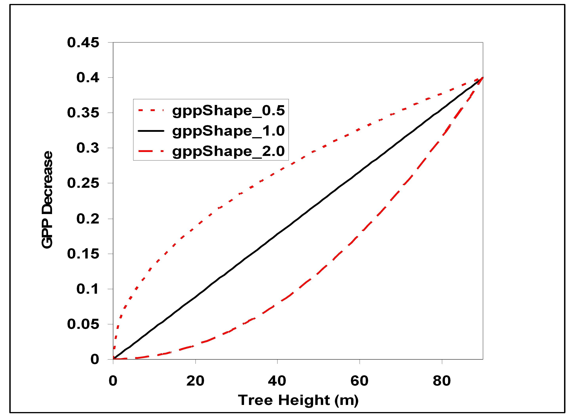

Figure 8-2. Reduction in GPP associated with tree height for different values of the GPPShape parameter. The maximum reduction in this example was assumed to be 40%.

in Gross Primary Production (GPP) as trees age. Although this is still a working hypothesis, we have included it in this version of the model to test its possible effects on carbon stores. This effect is implemented for upper and lower trees. The first step is to determine the coefficient (GPPDecreaseRate) describing the decline in GPP as height increases. This based on the maximum decrease in GPP (GPPDecreaseMax) that occurs at maximum tree height (HeightMax):

GPPDecreaseRate=GPPDecreaseMax/100*HeightMax^{GPPShape}

where GPPShape is a constant that determines if the decrease in GPP with height is linear, or quadratic in form. The predicted decrease for a given tree height (GPPDecrease) is given by:

GPPDecrease=GPPDecreaseRate *Height^{GPPShape}

where Height is the current height (m) of the upper or lower tree in a cohort as calculated in the NEIGHBOR module.

Allocation Function.

This function allocates production by the foliage to the following plant parts: fine roots, sapwood, branches, and coarse roots. There are several assumptions used in the calculation of fine roots, sapwood, branch, fine root, and coarse root production. The first is that production of these parts is proportional to the mass of foliage of each layer. The second is that the proportions of allocation to bole (i.e., sapwood and heartwood), branches, and coarse roots are fixed. The latter assumption is based on the idea that these structural elements need to be balanced to function properly. Although the allocation of production to these parts is fixed, this does not mean that the portions of parts is constant. This is because loss of parts, as calculated by MORTALITY, is a function of the amount of light absorbed by a cell. Therefore, cohorts with less light absorbed (and therefore less competition) will have proportionally more branches, and coarse roots than those where the maximum amount of light has been absorbed.

We assume that there is a fixed ratio (LayerFineRootAllocationRatio) between the allocation to fine roots and foliage mass. This ratio is life-form specific (herbs, shrubs and trees) and defined in the Growth.prm file. This assumption implies that the energy and nutrient gathering portions of plants are in balance. This ratio is assumed to be highest for herbs, intermediate for shrubs, and lowest for trees giving the highest allocation of biomass below ground for herbaceous plants and lowest for trees. The allocation to fine roots is calculated as:

LayerFineRootAlloc=LayerFineRootAllocationRatio*LayerFoliage

The allocation to woody plant parts can be determined by two methods. The first is based on a calibration to yield curves. This will set the growth rate so that the wood volume matches that of a specified level of productivity or site index for a selected species. If this option is specified in the Simul.drv file, then the variable LayerGrowthRate is set to value referred to in the SiteIndex.prm file. LayerGrowthRate can be thought of as the ability of foliage to form other tissues.

The second method used to determine the allocation to woody parts is to base the growth rate on climatic indices calculated in CLIMATE. If this option is specified in Simul.drv, then:

LayerGrowthRate=LayerAnnualProdIndex*LayerGrowthEffic

where LayerAnnualProdIndex is the effect of temperature and moisture on growth for a layer and LayerGrowthEffic is the growth efficiency for a layer as specified in the GrowParm.prm file.

Regardless of the method used to determine the allocation to woody parts, the mass of production allocated from foliage to sapwood is:

LayerSapWoodAlloc=(1-GPPDecrease)*LayerGrowthRate*LayerFoliage

where GPPDecrease is the decrease in GPP due to hydraulic limitations (set equal to 0 for all non-tree layers), LayerSapWoodAlloc is the mass of sapwood produced by a layer, LayerFoliage is the mass of foliage of a layer, and LayerGrowthRate is the ratio of wood mass produced to foliage mass. This relationship makes sapwood production reach a maximum when foliage mass is at a maximum. If foliage mass is reduced by thinning or shading then the rate of sapwood production will also be reduced until foliage is regrown.

The amount of production allocated to branches from foliage for trees and shrubs (LayerBranchAlloc) is equal to a fixed proportion of the rate of sapwood production for that layer. The parameter LayerBranchBoleRatio defines the ratio of branch to sapwood production. This parameter is set to give the proportions of a tree greater than 50 cm diameter at breast height as solved by biomass equations (Means et al. 1994). The mass of branches produced for a layer is therefore:

LayerBranchAlloc=LayerBranchBoleRatio*LayerSapWoodAlloc

The mass of production allocated to coarse roots from foliage (LayerCoarseRootAlloc) for the tree and shrub layers is calculated in manner similar to branches:

LayerCoarseRootAlloc=LayerCoarseRootBoleRatio*LayerSapWoodAlloc

where LayerCoarseRootBoleRatio is the ratio of coarse root to sapwood production of a layer as defined in the Growth.prm file.

Respiration Function.

The purpose of this function is to estimate the respiration of the plant parts for each layer. Foliage, fine roots, branches, sapwood, heart-rot, and coarse roots all are capable of respiring. Heartwood is not capable of respiring. For fine roots, branches, sapwood, heart-rot, and coarse roots losses from respiration are used to calculate the net change of those parts in the Live Stores function (see below). The respiration losses of all plant parts except heartwood are estimated from their mass:

LayerPartResp=LayerPartRespRate*LayerPart.

where LayerPartResp is the mass of production that is respired by a plant part, LayerPartRespRate is the rate as a proportion of each part, and LayerPart is the mass of each part for a layer the previous annual time step. LayerPartRespRate is calculated as a function of the species and the annual respiration index for each part of a plant layer. The latter variable is calculated in the CLIMATE module. For all plant parts the proportion of mass respired each year is:

LayerPartRespRate=LayerRespPart10 *LayerPartRespIndexAnnual

where LayerRespPart10 is the respiration rate of the plant part at 10 C.

For foliage, fine roots, branches, and coarse roots the fraction that is alive is constant among species and layers. In the case of sapwood, adjustments are made to LayerRespSapwood10 to reflect the fact that tree species have differing proportions of the sapwood that is alive. The respiration rate for sapwood contained in the GrowLayer.prm file is based on a living sapwood fraction of 5%. The rates used are based on respiration of lodgepole pine and Engelmann spruce (Ryan 1990). This base rate is adjusted by:

LayerRespSapwood10=LayerRespSapwood10*(LayerSapLive/5)

where LayerSapLive is the percentage of the sapwood of a layer that is alive. This parameter is stored in the Growth.prm file and is tree species specific based on the relative differences in sapwood core respiration by Pruyn et al (200?).

For foliage, fine roots, branches, and coarse roots the fraction that is alive is constant among species and layers. In the case of sapwood, adjustments are made to LayerRespSapwood10 to reflect the fact that tree species have differing proportions of the sapwood that is alive. The respiration rate for sapwood contained in the GrowLayer.prm file is based on a living sapwood fraction of 5%. The rates used are based on respiration of lodgepole pine and Engelmann spruce (Ryan 1990). This base rate is adjusted by:

LayerRespSapwood10=LayerRespSapwood10*(LayerSapLive/5)

where LayerSapLive is the percentage of the sapwood of a layer that is alive. This parameter is stored in the Growth.prm file and is tree species specific based on the relative differences in sapwood core respiration.

Heartwood Formation Function.

This function calculates the rate that heartwood is formed from sapwood for the tree layers (Figure 8-3). The mass transferred from sapwood to heartwood (LayerHeartWoodAlloc) for each tree layer is determined by the rate of heartwood formation (LayerRateHeartWoodForm) and the mass of sapwood (LayerSapWood) for the previous time step:

LayerHeartWoodAlloc=LayerRateHeartWoodForm*LayerSapWood

LayerRateHeartWoodForm is parameterized so that the proportion of boles in sapwood matches the values in mature trees of the various tree species.

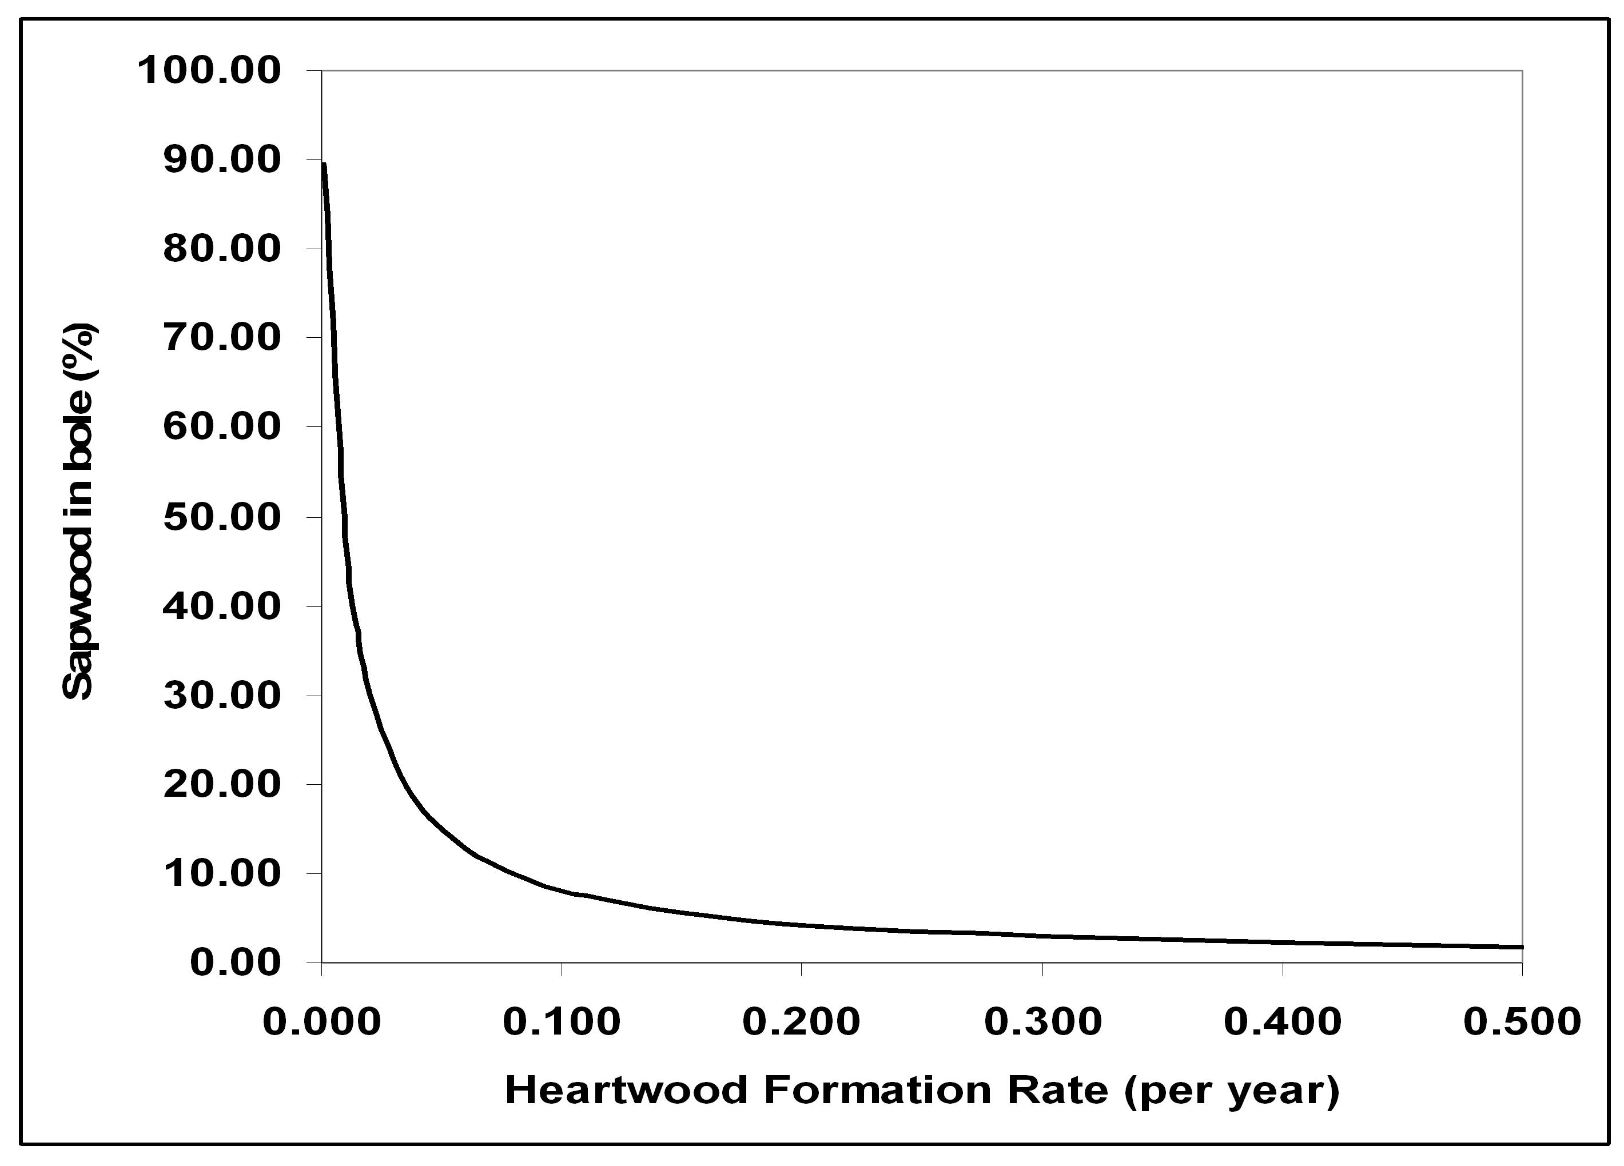

Figure 8-3. Influence of the Heartwood Formation Rate parameter on the fraction of sapwood in the bole of trees without heart-rot in the LANDCARB model.

Heartrot Function.

This function calculates the rate that heartrot is formed from heartwood for the tree layers (Figure 8-4). For each species there is a characteristic time lag before heart-rots become significant (Harmon et al. 1996). This time lag (HeartRotLag) is set in the Growth.prm file for each tree 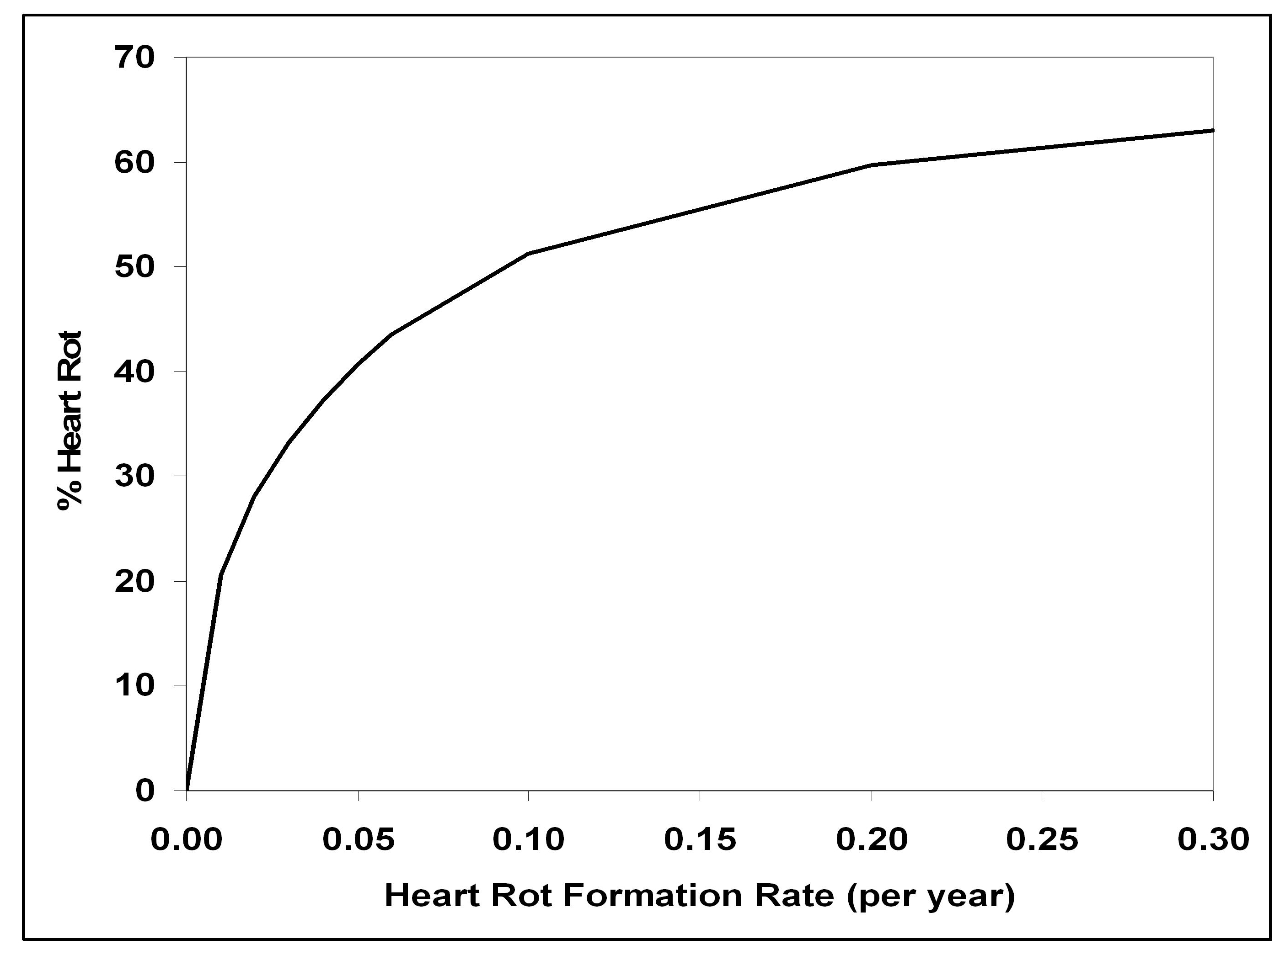

Figure 8-4. Influence of Heart-Rot Formation rate parameter on the fraction of wood that has heart-rot in the LANDCARB model.

species. If the time a layer has occupied a cohort is less than the time lag, then no heartwood is allocated to heart-rot. If the time a layer has occupied a cell equals or exceeds this lag, then the rate mass is transferred from heartwood to heart-rot (LayerHeartRotAlloc).

While only two tree layers are explicitly modeled (the upper and lower trees), conceptually we need to consider three because the lower tree eventually is replaced by a new generation of lower trees many of which do not contain heart-rot. We vary the rate mass is transferred from heartwood to heart-rot (LayerHeartRotAlloc) so as to reflect effect of the age-class structure of the layer and the fact not all trees will be infected by heart-rot at the same age. The latter is based on the assumption that once the trees in an age-class pass the time lag associated with heart-rot formation, then there is a window in which they all become infected by heart-rots. This window is defined by the variable ProbHeartRotMax in the herb line of the Growth.rpm file in the rate heart-rot formation column.

The lag time to heart-rot formation differs for the three tree layers (recall that one, the second generation of lower trees is a virtual tree layer that exists in concept). For the upper tree, lag time to heart-rot formation is the value in the Growth.prm for the species occupying the upper tree layer (HeartRotLag). The value used for first generation of lower trees is the sum of the TimeClose and TimeCloseWindow for upper trees plus the heart-rot formation lag (HeartRotLag) for lower trees noted in the Growth.prm file. This means that the lower trees cannot have heart-rot until they are released by the dieout of the upper trees and the lower tree heart-rot formation lag is exceeded. The value used for the second generation of lower tree is the the sum of the TimeClose and TimeCloseWindow for the lower tree and upper tree layer. The latter term is used not to indicate when the heart-rot begins for this virtual layer, but to indicate when the transition from the first and second generation of the lower tree begins. This is because the second generation of lower trees has an all aged-structure, some of these trees have heart-rot, while others do not.

The age-class distribution to be used also varies with the tree layer being considered. For the upper trees, the age class structure is determined by the rates of upper tree colonization as set by the Estab.prm file. For the first generation of the lower trees, the age-class structure is determined by the rate that upper trees die-out, a distribution described by the upper tree ExtRate parameter (see Die-out Module). This accounts for the fact lower trees may be present, but they only become large trees susceptible to heart-rot when upper trees start to die out. For the second generation of the lower trees we do not have an age-class distribution per se, but we do track the relative importance of the first and second generation of lower trees. We assume that the age-class distribution of the second generation of lower trees is stable and does not change in time and that it is created by the dying out of the first generation as described by the ExtRate for lower trees.

For the upper trees and the first generation of lower trees a joint probability distribution derived from the age-class structure of trees in a cohort and the ProbHeartRotMax parameter is used to transition from no heart-rot formation to the maximum rate of heart-rot formation for each species as defined by LayerRateHeartRotForm on the herb line in the Growth.prm file.

The cumulative probability of heart-rot once a tree passes the age of the heart-rot lag is varied non-linearly over time:

ProbHeartRot=(1-exp[-ProbHeartRotMax*(TimeThere-HeartRotLag)])^^{HRShape}

Where HRShape is the value stored in the shrub line of the Growth.rpm file and the rate heart-rot formation column. The probability of becoming infected with a heart-rot for any year once the heart-rot lag is passed is the difference in the cumulative probability from one year to the next.

For the second generation of lower trees, we assume that once the upper tree layer has died out and first generation of the lower trees has started to die out, that an all-aged structure developes. This means that some trees are too young to have heart-rot, while others are of sufficient age to have heart-rot. This effectively lowers the average rate of heart-rot formation. The amount of decrease depends on the proportion of the second lower tree layer that is too young to have heart-rot.

Once the time lag for the second generation of lower trees is passed the proportion of the second generation of lower trees is:

PropSecondGenLT= (1- exp[-LTExtRate*TimeSecondGen) ²

Where LTExtRate is the extinction rate of the lower trees and TimeSecondGen is the time since the second generation started to form which is equal to:

TimeSecondGen=Time-TimeLagSecondGen

Where TimeLagSecondGen is the sum of the upper tree and lower tree TimeClose plus TimeCloseWindow values. Note that before TimeLag2ndGen the proportion of second generation lower trees is assumed to be zero.

The relative rate of heart-rot formation once the second generation of lower trees has become completely established is a function of the proportion of second generation lower trees that are old enough to have heart-rot. This proportion is determined as:

RelHRForm2ndGen=(1-exp[-LTExtRate*TimeWithHR]) ²

Where

TimeWithHR = (3/LTExtRate)-LT HeartRotLag-(3/ProbHeartRotMax)

The last equation computes the number of years of the second generation has heart-rot.

The relative adjustment for heart-rot formation once the first generation of lower trees begins to die out (or conversely once the time lag for the second generation of lower tree is exceeded) is:

SecondGenHRAdjust= RelHRForm2ndGen+ (1- RelHRForm2ndGen)*(1- PropSecondGenLT)

Heart-rotFor each tree layer the mass of heartwood formed in a year is determined by the rate of heartrot formation (LayerRateHeartRotForm) and the mass of heartwood (LayerHeartWood) from the previous time step:

LayerHeartRotAlloc=LayerRateHeartRotForm*LayerHeartWood

LayerRateHeartRotForm is parameterized so that the proportion of boles in heartrot matches the values in mature trees of the various tree species (Harmon et al. 1996b).

Mortality Function.

This function calculates the mass of all plant parts lost by normal mortality processes. Even without harvest or wildfire some of the trees in a cohort are subject to mortality caused by competition (self thinning), wind, insects, and pathogens. It is assumed that when trees are subject to natural mortality, all the plant parts for that tree are added to detrital pools. The equation describing these losses is:

LayerPartMort=LayerMortalityRate*LayerPart

LayerMortalityRate is the proportion of trees dying and is calculated in the MORTALITY module and LayerPart is the mass of a layer from the previous time step . This parameter does not remain constant, but increases as the amount of light absorbed increases so that when the maximum amount of light is absorbed, the maximum mortality rate is reached. This mimics the increased competition among individuals as the canopy closes.

Prune Function.

This function calculates the mass of foliage, fine roots, branches, and coarse roots that are lost to litterfall, fine root turnover, or pruning.

The mass of these non-woody plant parts for each layer lost to these processes is:

LayerPartTurnover=LayerPartTurnoverRate*LayerPart

where LayerPartTurnover is the mass of non-woody plant parts of a layer lost from normal foliage fall and fine root turnover, LayerPart is the mass from the previous time step of the live part being considered, and LayerPartTurnoverRate is the fraction of the part for a layer that is dying in a given year. LayerPartTurnoverRate has different names depending upon the plant part considered. FoliageTurnoverRate and FRootTurnoverRate are used for foliage and fine roots respectively

The mass of these woody plant parts for each layer lost to these processes is:

LayerPartPrune=LayerPartPruneRate*LayerPart

where LayerPartPrune is the mass of plant parts of a layer lost from pruning, LayerPart is the mass from the previous time step of the live part being considered, and LayerPartPruneRate is the fraction of the part for a layer that is pruned in a given year. LayerPartPruneRate has different names depending upon the plant part considered. BranchPruneRate and CRootPruneRate are used for branches and coarse roots, respectively.

Live Stores Function.

This function calculates the mass of the plant parts after normal growth and mortality. The change in mass for each plant part caused by harvest and fire are calculated by HARVEST, PERSCRIBED FIRE and WILDFIRE, respectively. The balance of foliage is calculated as follows:

LayerPart = LayerPartOld + LayerPartAlloc

Where LayerPartOld is the mass of the part from the previous year, and LayerPartAlloc is the mass of the plant part produced

For fine roots the mass in any year is:

LayerPart = LayerFineRootOld + LayerFineRootAlloc –LayerFineRootResp
- LayerFineRootTurnover-LayerFineRootMort

Where LayerFineRootOld is the mass of the fine roots from the previous year, LayerFineRootAlloc is the mass of fine roots produced , LayerFineRootResp is the mass respired, LayerFineRootTurnover is the mass of fine roots lost to turnover, and LayerFineRootMort is the mass dying with boles because of normal mortality

For branches and coarse roots the mass in any year is:

LayerPart = LayerPartOld + LayerPartAlloc -LayerPartResp- LayerPartPrune
-LayerPartMort

Where LayerPartOld is the mass of the part from the previous year, LayerPartAlloc is the mass of the plant part produced (for branches this is LayerBranchAlloc and for coarse roots this is LayerCoarseRootAlloc), LayerPart is the mass of plant part for that year, LayerPartResp is the mass respired, LayerPartPrune is the mass pruned, and LayerPartMort is the mass dying with boles because of normal mortality

The mass of sapwood for a layer is calculated as:

LayerPart = LayerPartOld + LayerPartAlloc -LayerPartResp
-LayerSapWoodHeartWoodAlloc-LayerPartMort

where all the variables are the same as for branches and coarse roots except that LayerSapWoodHeartWoodAlloc is the mass of sapwood allocated to heartwood.

The mass of heartwood for a layer is calculated as:

LayerPart = LayerPartOld + LayerPartAlloc -LayerPartMort-LayerHeartRotAlloc

where all the variables, except LayerHeartRotAlloc, the allocation to heart-rot, are defined as for the other plant parts. In the case of heartwood LayerPartAlloc is LayerSapWoodHeartWoodAlloc, the mass of sapwood allocated to heartwood formation.

The mass of heart-rot for a layer is calculated as:

LayerHeartrot= LayerHeartrotOld + LayerHeartrotAlloc -LayerHeartrotResp
-LayerHeartrotMort

where all the variables are the same as above.

In addition to these plant parts the mass in boles for the upper or lower tree layers is calculated as

LayerBole=LayerSapwood+LayerHeartwood.

The total live mass is the sum of all the live parts:

LayerTotalLive=Σ LayerPart

where LayerPart is the mass of the part for each layer. In addition to these totals, the total mass of each part is also summed across all the layers.

